SQL ASSIGNMENT 07

Q1.Write a query that counts all orders for October 3.
Ans.

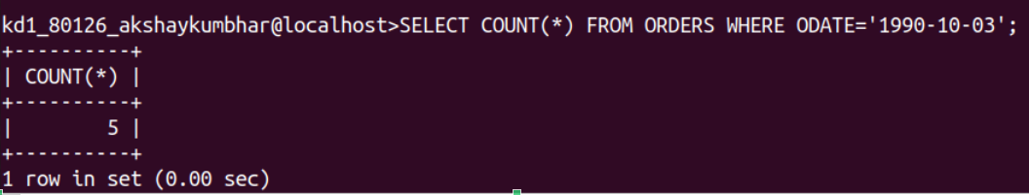
Q2.Write a query that counts the number of different non-null city values in the Customers table.
Ans.
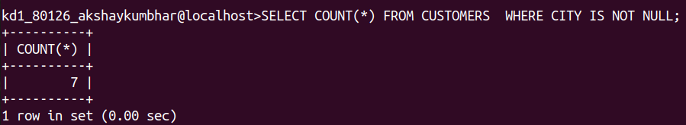
Q3.Write a query that selects each customer’s smallest order.
Ans.
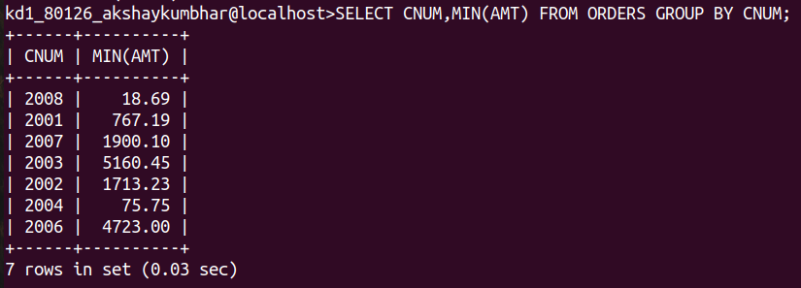

Q4.Write a query that selects the first customer, in alphabetical order,whose name begins with ‘G’.
Ans.
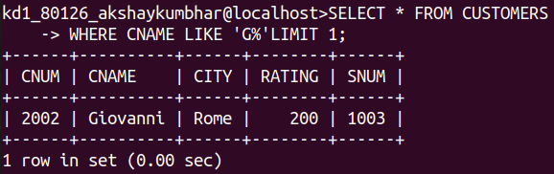
Q5.Write a query that selects the highest rating in each city.
Ans.
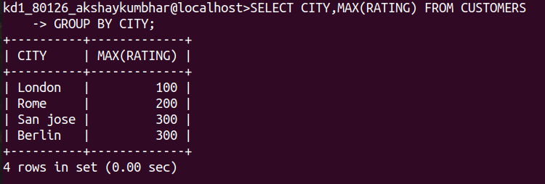
Q6.Write a query that counts the number of Salespeople registering orders for each day.(If a Salesperson has more than one order on a given day he or she should be counted only once).
Ans.
